Chatbot Functional Testing Report

Sprint 2
AI Assistant for HR
Nihal Reddy
Dev 2

Purpose
The purpose of this task was to perform basic functional testing of the chatbot page developed. At this stage, the chatbot was intentionally designed to provide only basic functionality. Complex workflow logic, behavioural rules and escalation logic were not yet implemented. Therefore, testing focused on confirming that:
- the deployed application loaded successfully
- the Chatbot tab was available through the application navigation
- the chatbot page could be accessed
- the Gemini API was correctly connected in the deployed environment
- the chatbot could accept a user message
- the chatbot could return a response.
Testing was performed across multiple deployments provided by the developer. Issues identified during testing were documented and communicated to the developer, followed by retesting of updated deployments.

Issue 1: Gemini API not configured in Deployment
Defect: 1
Deployment: 1
Component: Gemini API Integration
Status: Fixed
During testing of the first deployed version, the Chatbot page was available through the application. However, the deployed environment was not correctly configured with the Gemini API key.
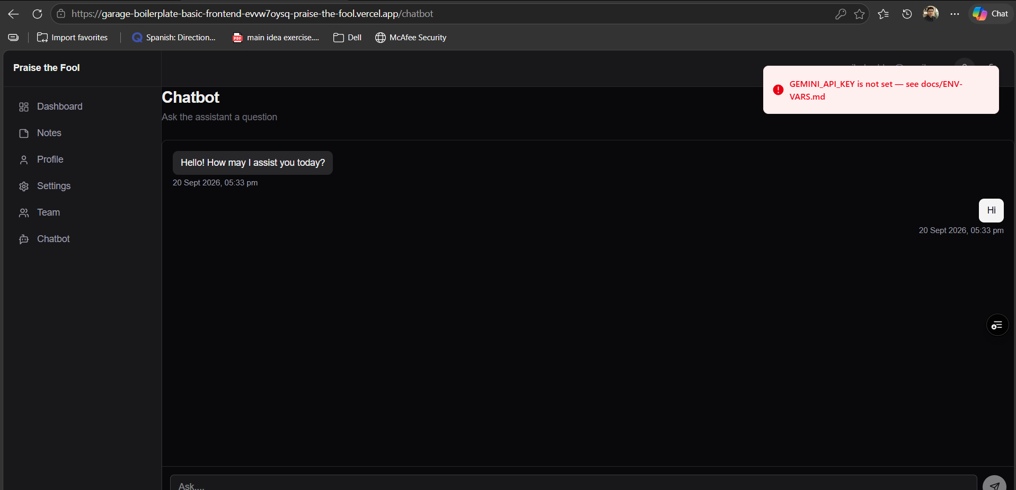
Steps in Testing:
- Open Deployment link.
- Navigate to Chatbot Tab in the left navigation bar.
- Open the chatbot page.
- Greeted with message from bot.
- Interact with bot by posting a message.
- Observer the API configuration error displayed by the application.
Expected Behaviour
The Gemini API should be configured in the deployed environment so that the chatbot can receive a user's message and return an AI-generated response.
Actual Behaviour
The chatbot's core functionality was unavailable. Although users could access the page, they could not successfully use the AI assistant. The issue was documented and communicated to the developer so that the deployment/environment configuration could be corrected. Message: GEMINI_API_KEY is not set — see docs/ENV-VARS.
Issue 2: Chatbot Navigation Tab Missing
Defect: 2
Deployment: 2
Component: Chatbot Navigation
Status: Fixed
The second deployment identified that the Chatbot option was missing from the application's left navigation sidebar. The sidebar contained options including Dashboard, Notes, Profile, Settings and Team, but no Chatbot tab was available.
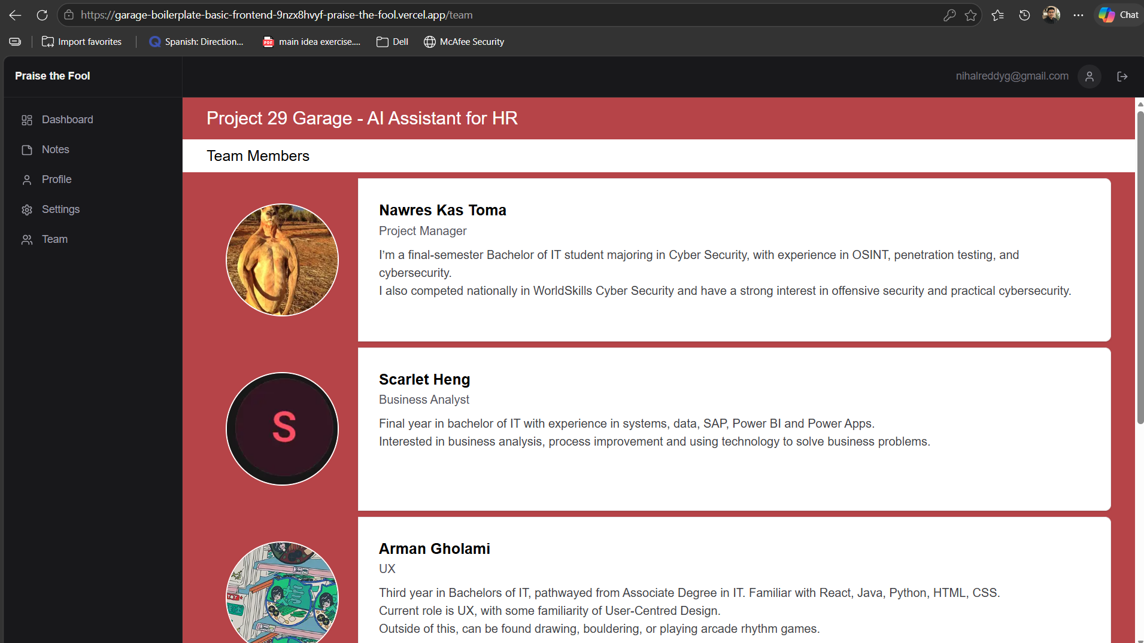
Steps in Testing:
- Open Second updated Deployment link.
- Inspect the navigation sidebar.
- Trying to locate the chatbot navigation tab.
Expected Behaviour
The left navigation sidebar should contain a Chatbot tab so that users can access the chatbot feature directly from the application.
Actual Behaviour
The Chatbot navigation option was not displayed. No other way to access the chatbot page. The navigation issue was documented and communicated to the developer for correction.

Final Deployment
Deployment: 3
Verification | Result
Application loads successfully | PASS
Chatbot Tab is displayed in navigation bar | PASS
Chatbot Page opens | PASS
User is greeted with initial message | PASS
User can enter and send message to bot | PASS
Gemini API is connected | PASS
Chatbot returns an AI response | PASS
No issue identified during functional testing. | PASS
The final deployment therefore met the basic functional requirements expected for the Sprint 1 chatbot implementation.
This testing only verifies the current basic chatbot functionality. Complex behavioural logic, workflow decision-making and escalation rules are outside the scope of this functional test because those features have not yet been implemented.
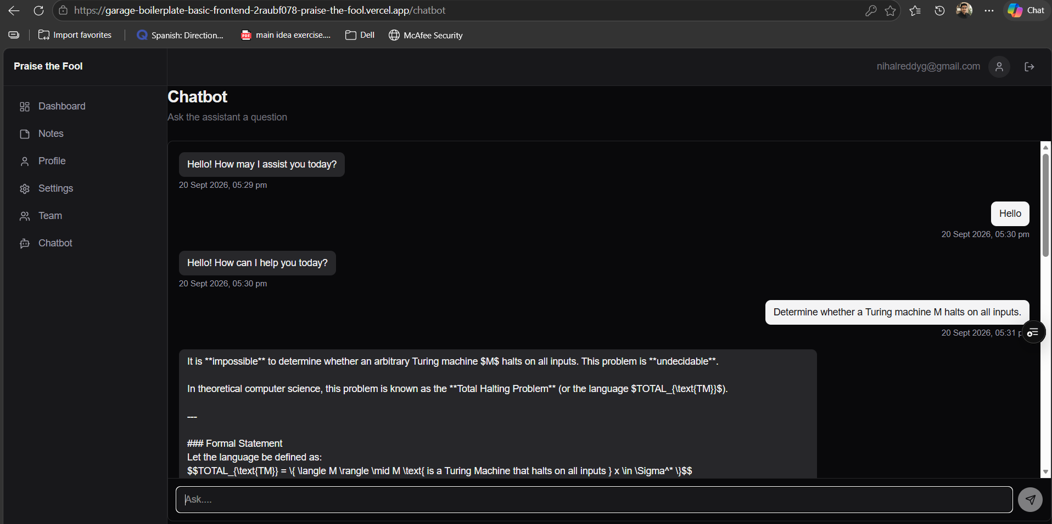
Outcome
The first deployment exposed a configuration issue where the Gemini API key was unavailable in the deployed environment. The second deployment corrected this area but introduced/contained an accessibility issue where the Chatbot tab was absent from the application's navigation.
Both issues were documented and communicated to the developer. Following the corrections, the third deployment was retested and successfully provided the required Sprint 2 functionality.

